PROGRAM CODE
#include <stdio.h>
void main()
{
int n, m, i, j, k;
printf("Number Of Processes = ");
scanf("%d",&n);
printf("Number Of Resources = ");
scanf("%d",&m);
int alloc[n][m];
int max[n][m];
int avail[m];
printf("ALLOCATED MATRIX \n");
for(int i=0;i<n;i++){
for(int j=0;j<m;j++){
scanf("%d",&alloc[i][j]);
}
}
printf("MAX MATRIX \n");
for(int i=0;i<n;i++){
for(int j=0;j<m;j++){
scanf("%d",&max[i][j]);
}
}
printf("AVAILABLE RESOURCES\n");
scanf("%d %d %d %d",&avail[0],&avail[1],&avail[2],&avail[3]);
int f[n], ans[n], ind = 0;
for (k = 0; k < n; k++) {
f[k] = 0;
}
int need[n][m];
for (i = 0; i < n; i++) {
for (j = 0; j < m; j++)
need[i][j] = max[i][j] - alloc[i][j];
}
int y = 0;
for (k = 0; k < 5; k++) {
for (i = 0; i < n; i++) {
if (f[i] == 0) {
int flag = 0;
for (j = 0; j < m; j++) {
if (need[i][j] > avail[j]){
flag = 1;
break;
}
}
if (flag == 0) {
ans[ind++] = i;
for (y = 0; y < m; y++)
avail[y] += alloc[i][y];
f[i] = 1;
}
}
}
}
int flag = 1;
for(int i=0;i<n;i++)
{
if(f[i]==0)
{
flag=0;
printf("SYSTEM NOT SAFE");
break;
}
}
if(flag==1)
{
printf("SAFE Sequence >> ");
for (i = 0; i < n - 1; i++)
printf("P%d-> ", ans[i]);
printf("P%d\n", ans[n - 1]);
}
}
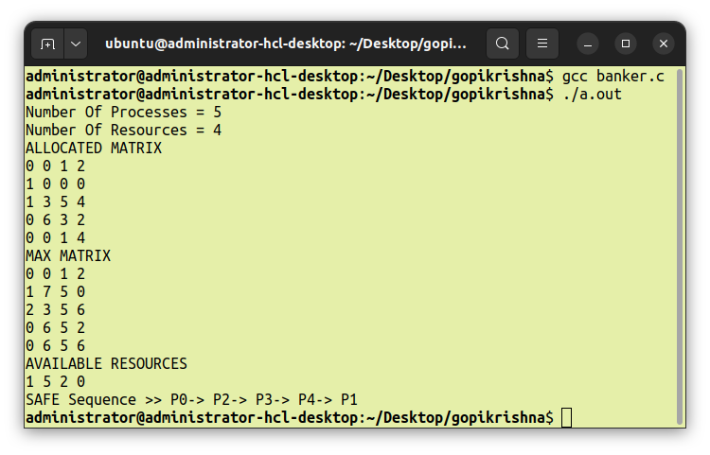
OUTPUT

